**Entity Relationship Diagram**

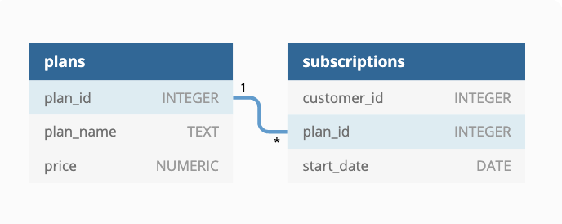

* One to many relationship between tables
* Plans is a parent table where plan_id column act as primary key, while subscriptions is a child table where plan_id column act as a foreign key.